First take 3 VM
Ubuntu Monitoring : 192.168.1.10
Ubuntu 1: 192.168.1.20
Ubuntu 2: 192.168.1.30
VM 1 : Ubuntu Monitoring
- sudo apt update
- sudo apt install python3-pip
- sudo apt install openssh-client
- pip install flask
- pip install paramiko
- pip install psutil
- pip install reportlab
- pip install apscheduler
- pip install flask_sqlalchemy
- pip install yagmail
- pip install panda
- sudo apt install sqlite3
- sudo apt install git
Folder Structure of VM1
- MonitoringSystem/
- app.py monitor.py
- ssh_monitor.py
- email_alert.py
- pdf_report.py
- database.py
- scheduler.py
- templates/
Index.html
- database.db

VM1 Responsibilities
- Flask Dashboard
- SSH to Servers
- Collect CPU
- Collect RAM
- Collect Disk
- Store Database
- Email Alerts
- Generate PDF
VM2 Ubuntu 1

- sudo apt update
- sudo apt install openssh-server
- sudo apt install net-tools
- sudo apt install sysstat
- sudo systemctl enable ssh
- sudo systemctl start ssh
- sudo apt install stress

VM3 Ubuntu 2

- sudo apt update

- sudo apt install openssh-server

- sudo apt install net-tools

- sudo apt install sysstat

- sudo apt install stress

All VM on NAT and HOST-Only Adapter

Three of VM can Communicate with each other with Ping

Enable SSH Password

On VM2 and VM3
Edit
sudo nano /etc/ssh/sshd_config
Set
PasswordAuthentication yes
Restart
sudo systemctl restart ssh

Test SSH

From VM1

ssh user@192.168.1.20

Step 1: Your Final Folder Structure (on VM1 only)

On VM1 (Monitoring Server), create the project folder:

mkdir InfrastructureMonitoring

cd InfrastructureMonitoring

InfrastructureMonitoring/
│
├── app.py
├── ssh_monitor.py
├── database.py
├── email_alert.py
├── pdf_report.py
├── requirements.txt
│
├── templates/
│ └── index.html
│
├── static/
│ ├── css/
│ └── js/
│
├── reports/
│
└── monitoring.db

Then make all Files and files and code of python

nano app.py

mkdir templates

For Run Application : python3 app.py

nano ssh_monitor.py

nano database.py

nano templates/index.html

ALL code Files are in Git Repo

This is How Daseboard Looklike in WebPage
This is for Ubunt 1 Monitoring
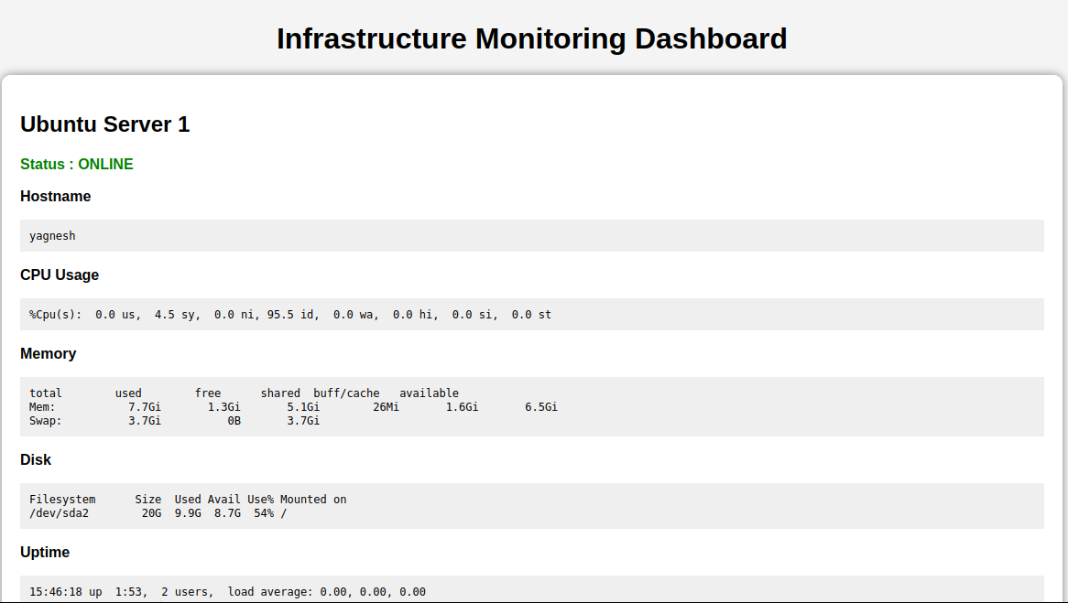

This is for Ubuntu 2 Monitoring

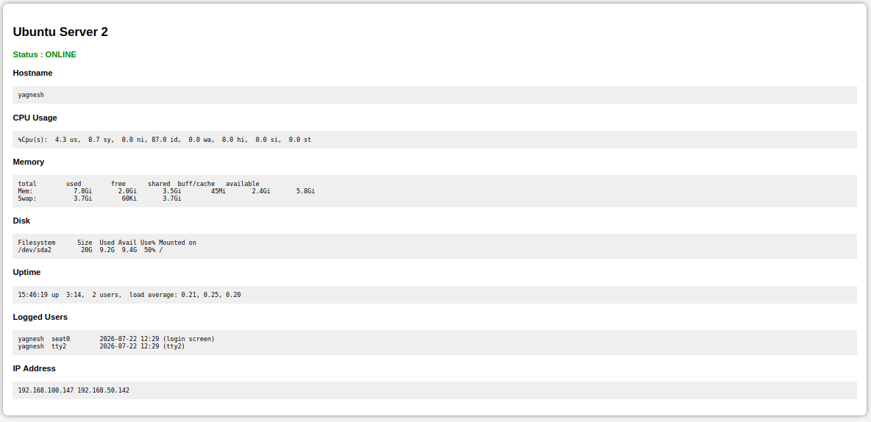

This output is of ssh_monitoring.py for Ubuntu 1 Monitoring
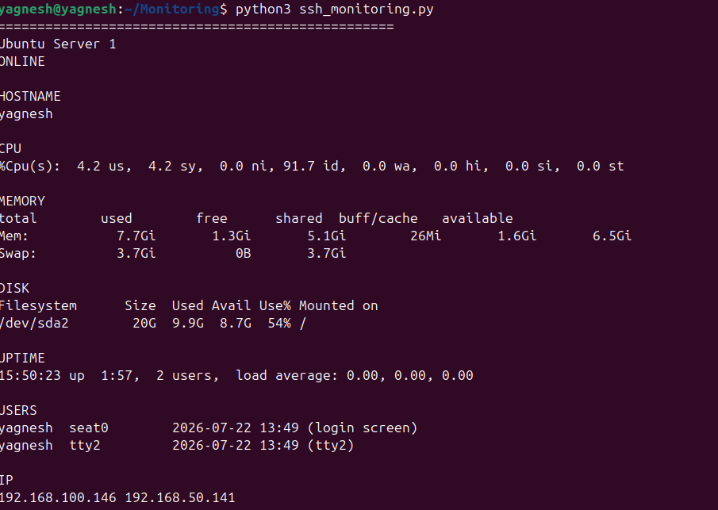

This is output of ssh_monitoring.py Ubuntu 2 Monitoring
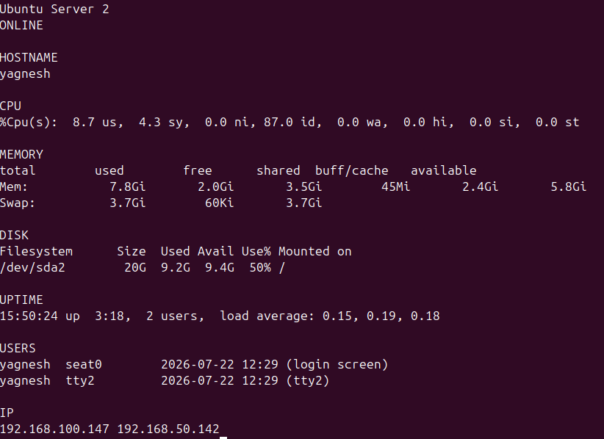

In this Report PDF Generation is there Left Bottom
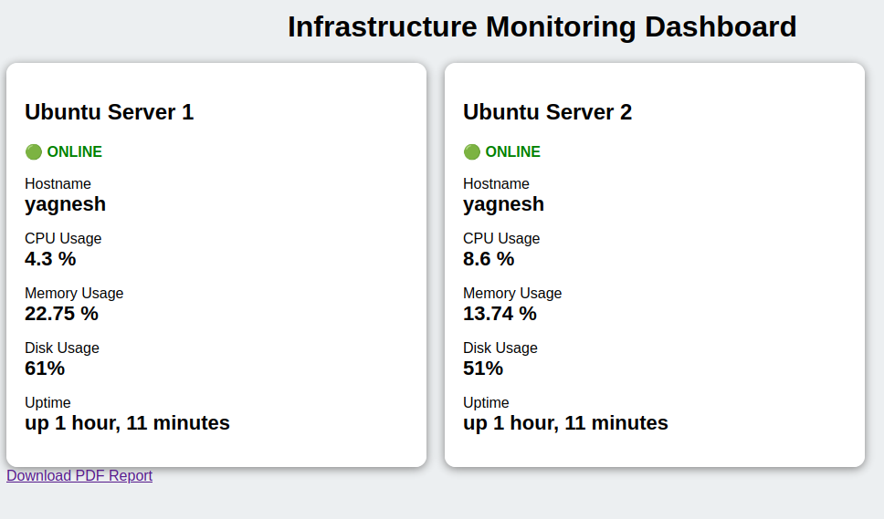
This command for close SSH Port
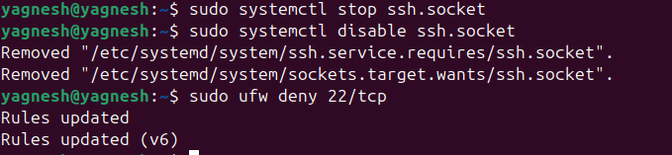
In this output Ubunt 1 ssh port is close
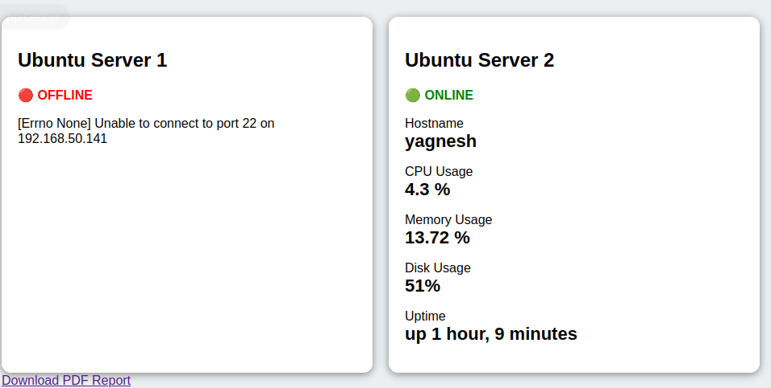

In this command is for start ssh again
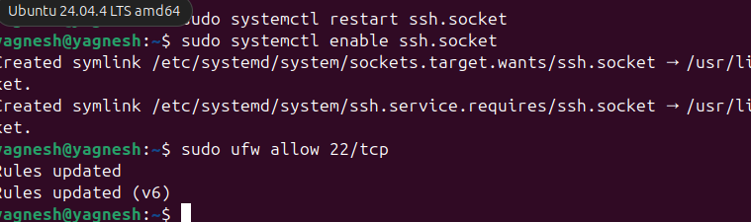

Again Both pc are Online


